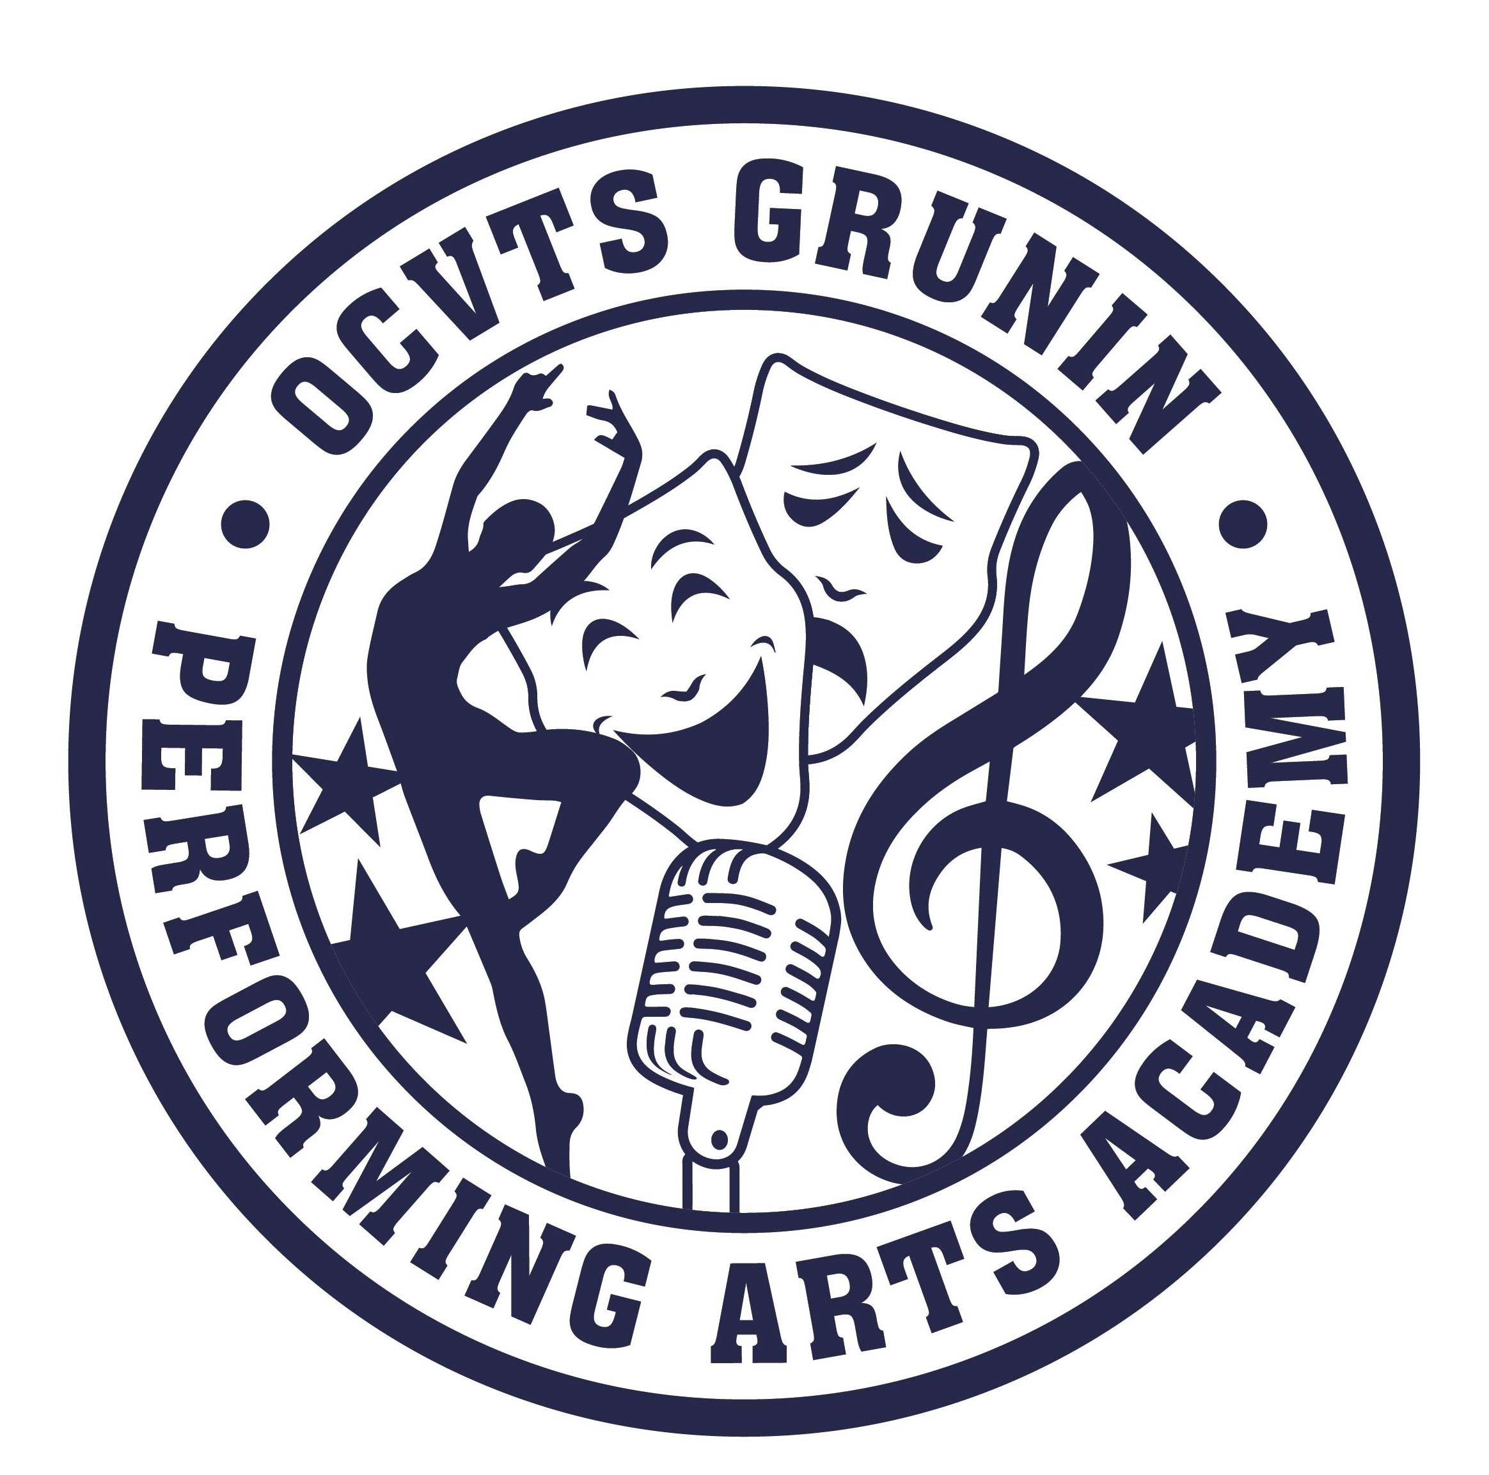
GPAA PTSO MEETING MINUTES
October 12, 2022 7:00pm Gia Prima Blac Box Theater

Officers In attendance: Daisy Haffner, President; Joylene Rock, Vice President;
Hilary Cocozziello, Secretary and Darlene Perucki, Treasurer
The meeting was called to order at 7:08pm by D. Haffner followed by the Pledge of Allegiance.
Ms. Haffner welcomed the attendees.

- GPAA Update – Tierney Meeker
  - Sophomores and Juniors took PSAT’s today;
  - Upcoming information Open House sessions for GPAA (Performance Troop no longer travels to schools) on 10/15, 10/19 and 11/19;
  - Wear Pink Day for Breast Cancer Awareness Month is Thurs 10/13 and NHS is giving out pink lapel ribbons;
  - Sat April 22nd has been confirmed for the Gift Auction;
  - Be sure to check parent portal and daily emails.
    - Forms for emergency contacts must be filled out so student will be permitted on field trips;
  - Halloween Dance to be announced in a day or two;
  - The Snowball winter semi-formal will be held in January date to be announced soon.

- Report on Fall Drama “CLUE” – Mr. Ciccotelli
  - T-shirts now on sale;
  - Tickets for all performances will be on sale soon;
  - Thank you to everyone who has donated snacks, drinks and their volunteer time to help make this show great;
  - Important – Looking for a set builder. In need of someone to build and put together the scenery for the show. Please forward any contacts to Mr. Ciccotelli.

- Vice President’s Report – Joylene Rock
  - Super 50-50
    - Thanks to Quinn-Hopping Funeral Home as the printing sponsor of our upcoming Super 50-50;
    - The drawing will be held during the Gift Auction on 4/22/22 at approximately 7pm
    - Tickets will be $5 each.

- Secretary’s Report – Hilary Cocozziello
  - Approval of May 2022 Minutes
    - Hilary asked for a motion to approve the minutes of the May 2022 PTSO meeting.
      - 1st – Mrs. Meeker
      - 2nd – K. Dudonis
      - Approve – All
      - No’s – None
      - Abstain – None

    - Hilary asked for a motion to approve the minutes of the September 2022 PTSO meeting
      - 1st – Mrs. Meeker
      - 2nd – P. East
      - Approve – All
      - No’s – None
      - Abstain – None
  - Reminders
    - Memberships must be paid by no later than December 22nd ;
    - Families/Students/Parents or Guardians must be members for three (3) years in order to be eligible for annual PTSO sponsored senior scholarships (selected and awarded by faculty and not PTSO).

- Treasurer’s Report – Darlene Perucki
  - The current balance of the checking account is $8,970;
  - Amazon Smile has brought in $130 to date for 2022
    - Our Amazon Smile account is “Parent Teacher Student Org of the Performing Arts Academy”
  - Fall apparel sale brought in $1,100;
  - Cheddar Up is available for food service payments for Clue Tech week. Link available on our website paaptso.org

- President’s Report – Daisy Haffner
  - Back to School night on 9/21 was well-attended. We received quite a few new members;
  - Beetlejuice trip had excellent attendance, and everyone enjoyed the event;
  - Looking into scheduling another Broadway trip for January;
  - Clothing Drive is December 7th and 8th in the parking lot Clean out our closets before the holidays! Full info can be found on our website “Events” page;
  - Donations are also welcome to our school nurse for the student closet;
  - Still looking into available bakeries for crumb cake sale for Thanksgiving time sale.

- Committee Reports
  - Food Service – Denise Holland and Joylene Rock
    - We still need parent volunteers to help with food service;
    - SignUp Genius has been emailed including volunteer signup and requests for snack/beverage donations;
    - Cheddar Up link is set up for all cast/crew to pay for food service on the website;
    - Please be sure to have food orders in no later than one week beforehand.
  - Apparel Sale – Kate Dudonis and Donna Ward
    - Fall sale merchandise will be handed out on Tuesday 10/20 before school. To make arrangements if unable to receive that day, please see Kate or Donna;
    - Next sale to run 10/31 – 11/13 with new items and a new customized logo on some merchandise;
    - Thanks to all for support of the PTSO and remember the funds raised go to our programs and year end scholarship sponsorships.
  - Refresh Your Pallet Fundraiser – Denise Holland
    - Event will be held in Black Box on Wed 11/9
    - Still time to sign up – link on website “Events’ page
      - Link takes you directly to Refresh Your Pallet site to create and design your piece and pay online
    - Beverages and snacks can be brought into the event.

  - Gift Auction – Darcie King
    - This year’s theme is “And the Beat Goes On” music through the decades;
    - We will need plenty of volunteers! Everything from soliciting for donations and making baskets to helping on the day of the auction.
    - Class basket themes: donations needed!
      - 2023 - Picnic
      - 2024 - Dine In and Out
      - 2025 - Desserts
      - 2026 - Beach Basket
    - Food Trucks in the parking lot and County stage in the lot will have entertainment
    - List of current needs and requests:
      - Homes to store donations and to host wrapping of baskets;
      - Donations and sponsorships – letters will be ready for prize solicitation once we have received license;
      - Ticket Sales
        - Reach out to senior communities (lots in immediate area)
      - Baskets, trays, frames etc for prize displays;
      - Envelopes (400-500) regular letter size;
      - All performances, shows, PTSO meetings we will be collecting Alcohol and wine for Booze Basket;
      - Prices will be $40 pre-sale for admission and ticket package and $45 at door. Ticket bundle will include a grand prize ticket this year;
    - Monthly meetings coming up – October 24th and November 28th at 7pm in the Black Box.

- There being no further business, at 8:04pm a motion was made by H. Cocozziello to adjourn the meeting. It was 2nd by P. East

